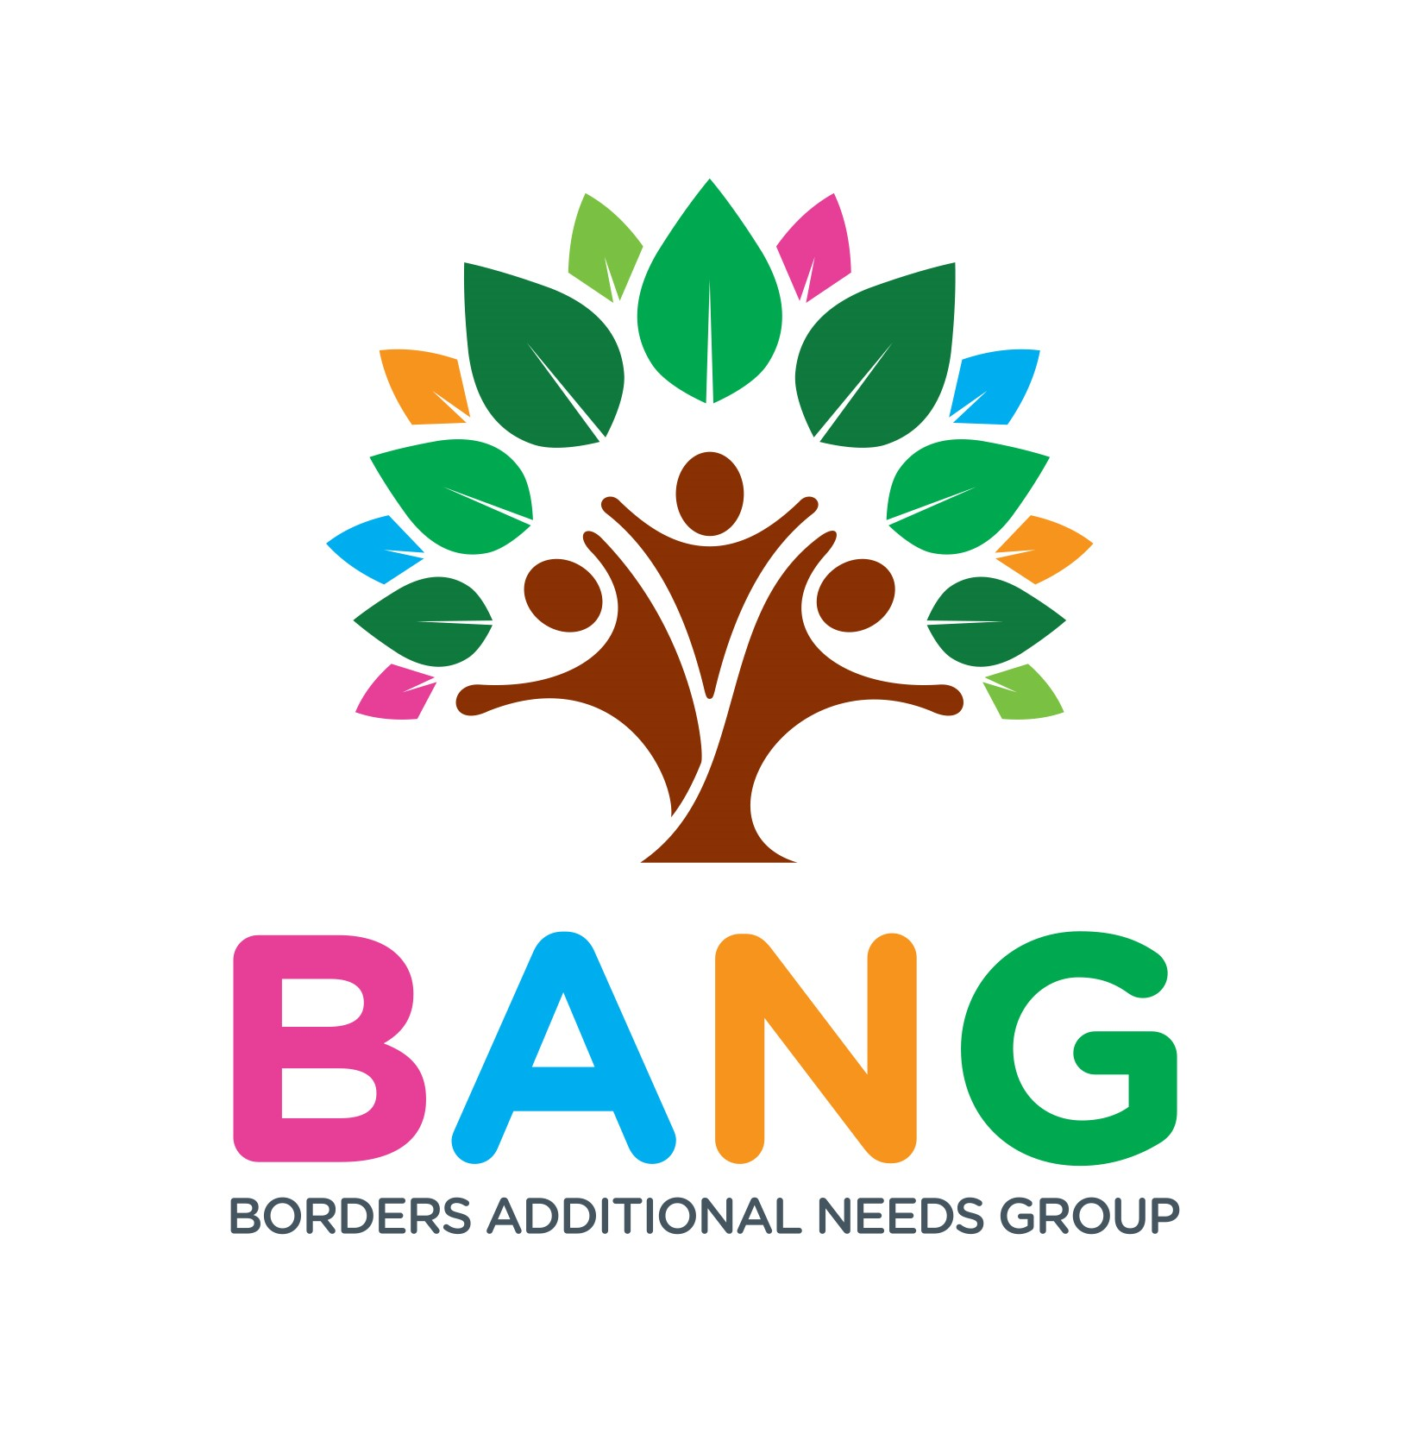
2020 BANG Covid- 19 Funding Application sponsored by National Lottery Awards for All Funding
Date Application Made
Name of Main Contact
( legal Guardian)
BANG Member:
Home Address and Postcode

Telephone Number:
E mail Address :

Child Applicants Name

Branching Out Youth Application

Brief Summary of Additional Need or social need
Does Child reside at main applicants address please Circle | Yes No

Purpose of the Grant ( max 50 words)

Tell us briefly how this funding will make a difference to you child and family

Item and Cost

Total cost : £

Signature of Main Person applying for the Grant

NB: This form will act as a formal agreement to receiving funding.
Please Note : Borders Additional Needs Group will distribute vouchers in the name of the main applicant
Terms and conditions
- BANG Covid-19 Grant are intended to help children that are experiencing temporary home-schooling difficulties, aim of the grant is to provide Sensory Toys and Books.
- The Grant can be used to support BANG Youths accessing the new Branching our Project, please indicate this on the form. Tablets can be purchased average price - £70-£80
- The Grant is not to be considered for other financial Hardships; BANG will signpost you to other funding support.
- The grant must only be used for the purposes set out in the funding application
- If you successful Borders Additional Needs group SCIO will Release voucher or Order you goods for your applicant and sent to your home address.
- Main applicant when signing the form agrees to the terms and conditions of the grant
- Main applicant must retain receipt of purchase and complete a funding evaluation form within one month of receiving the Grant
- Grant Decisions will be made by Two BANG Board members and agreed

If you require help to complete the form please contact BANG to Pauline Grigor CEO Paulinegrigor@tiscali.co.uk or Nicola Corbet BANG Secretary :bangsecretary@gmial.com

Date Form received :
Agreed By Board members please sign : | BANG Board signature: | Bang Board Signature:
Date funding released :
Grant sent to home
BANG order Goods
BANG confirmation of order and dates

