Borders Additional Needs Group SCIO
OSCR Registered SC049074
Development Action Plan 2019
And
ANNUAL REPORT 2018-19
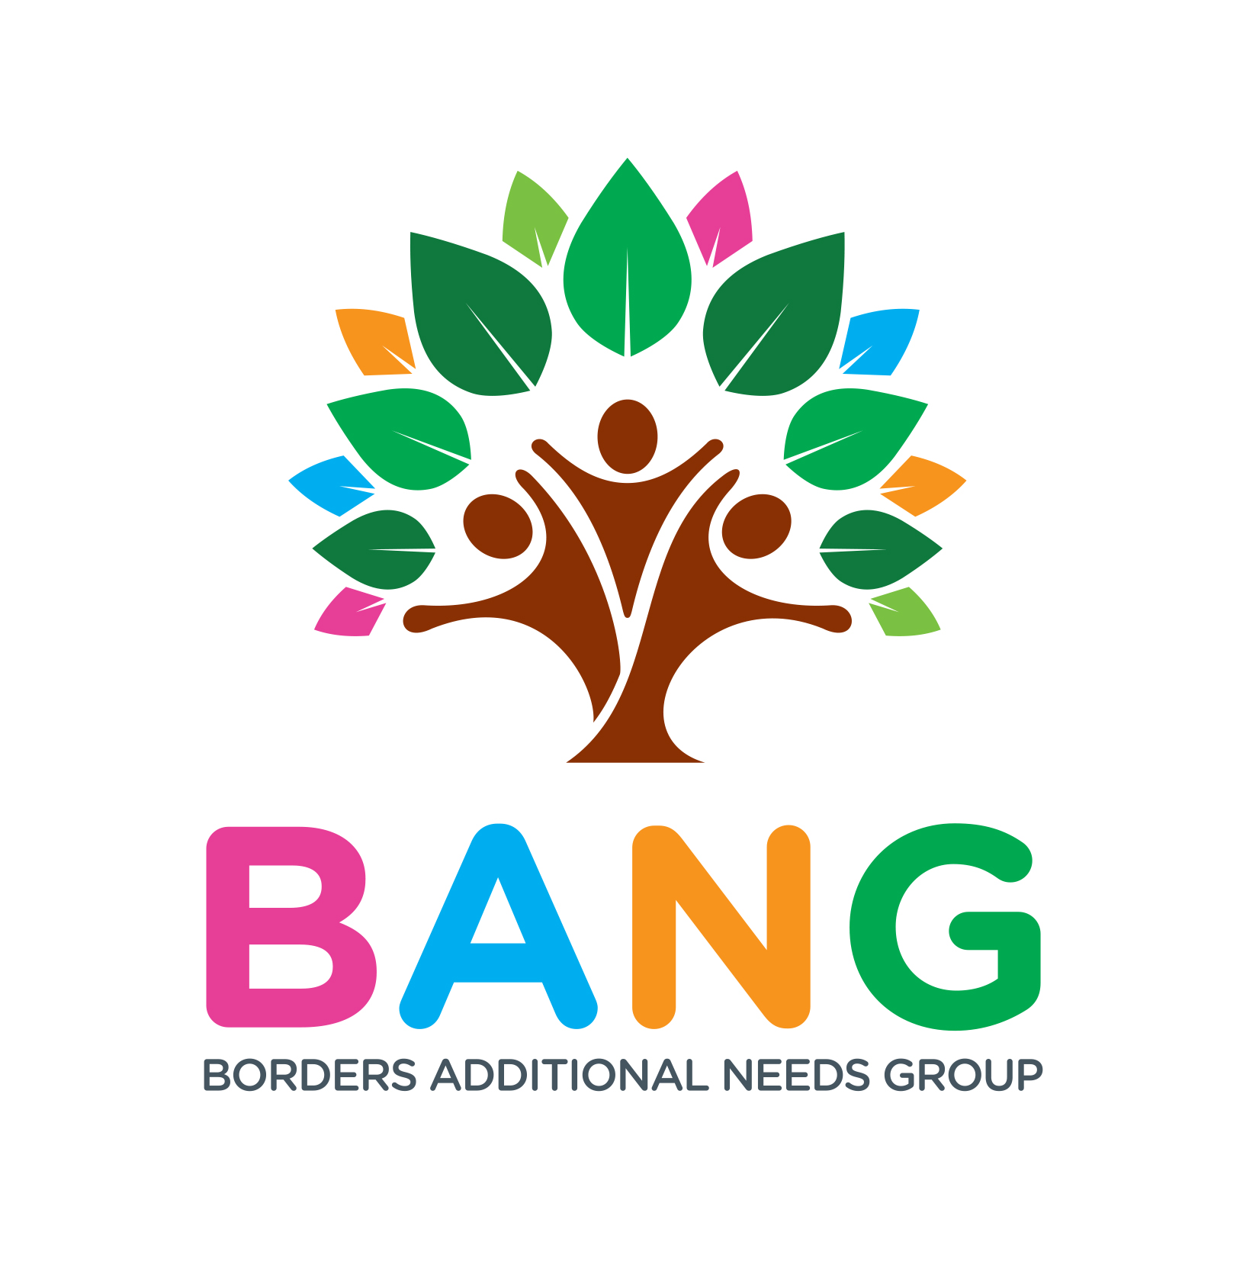

CONTENTS

ORGANISATION DETAILS and CHARITY TRUSTEES 3
PURPOSE OF THIS DOCUMENT 3
OUR VISION and MISSION STATEMENT 4
OUR HISTORY 4
OUR SERVICES and PRIORITIES 6 - 11

ORGANISATION DETAILS
Borders Additional Needs Group SCIO
10 Stobshaw Terrace
Tweedbank
TD1 3RN
OSCR Registered SC049774
Website : http://www.bordersadditionalneeds.org/aboutus.asp
E Mail : info@bordersadditionalneeds.org.uk

CHARITY TRUSTEES
Sara Fitch Chair retired teacher
Nicola Corbet Secretary parent carer and Primary School Additional Needs Assistant
Vivian Miller Treasurer parent carer
Pauline Grigor CEO parent carer, community development worker
Lorna Jamieson Trustee sports development/special needs
Kate Wrigley Trustee parent carer, GP

PURPOSE OF THIS DOCUMENT
This document aims to cover the final year’s activities for Borders Additional Needs Group (BANG), an unincorporated Scottish Charity as an Annual Report for 2018-19 ; it also comprises the forward Development Plan for Borders Additional Needs Group SCIO for 2019-21. We changed our legal structure to an incorporated charity in May 2019.

BANG Development Plan sets out the background to the organisation, its aims and objectives and how it Borders Additional Needs Group will seek to achieve these aims. BANG unincorporated charity SCO41955 undertook a 2 year plan to review its operation and set a clear vision forward, due to high demand for its services. Following a Management meeting development day in August 2017 with partners and members, it focused on diversification and development to meet the needs of its beneficiaries. Approval by its members was sought at the AGM in June 2018 to become a Scottish Charitable Incorporated Organisation to take forward those plans. BANG has since worked on updating polices and undertook a further 3-month consultation to develop a strong strategic vision for the new SCIO. This is outlined within this Development Plan.
The Development Plan for BANG SCIO seeks to :
- Provide a clear vision going forward
- Identify the key strands of our operation (beneficiaries): currently Parents, Youth, Junior
- Set clear priorities for each strand
- Identify potential partnership opportunities
This is an organic document that will allow BANG to respond to new opportunities as they arise. The vision of the organisation will be determined with the needs of its members at its core.

OUR VISION
To Put Families at The Heart of What We Do.

MISSION STATEMENT
- To ensure families have access to support, information and advice to help them manage the changes involved in raising an Additional Needs child.
- To support siblings and caregivers by providing them with training and peer support.
- To promote resilience and empower families to feel included and engaged in their child’s journey.
- To ensure the best possible outcomes for all families in the Scottish Borders raising a child with Additional Needs.

OUR HISTORY
Borders Additional Needs Group (BANG) was set up in 2003 in response to an identified need by parents of newly diagnosed Children with Additional Needs. The parents wanted to set up a Parent Led Support Group for families and care givers in the Scottish Borders, with a focus on addressing the changing needs of the family at the time of diagnosis. It would meet once a month, offer peer support and a safe place for the children. The group named it Borders Additional Needs Group also known as BANG.

The group was successful and in 2006 it became constituted with the support of the local TS1. The venue for the monthly meetings changed during this time but eventually settled on Tweedbank Community Centre. The direction for BANG was driven by the needs of the families - organised activities were very popular. The group compiled a directory of resources for the families to access at every meeting.

In late 2009 as demand for its services increased, the group registered with the OSCR and was granted charitable status as an unincorporated charity (SC041955). This development allowed the charity access to funding for a website and strengthened the focus on governance.

Borders Additional Needs Group has continued to grow and develop its services based on the needs of its members and families. BANG has:
- Developed a new Youth Sector in 2016 for young people aged 11 years and over and Young Carers
- Introduced Sensory Cinema Screening at the local cinema 4 times a year
- Organised many fun family day trips
- Taken part in Scottish Government Participation events
- Organised workshops and training
- Held Parent Celebration events
- Identified partnership opportunities and joined local networks
- Enhanced its profile on a local and national level

The Pathway to Change
Over time the needs of our families have changed with the newer families joining who lack knowledge of support services both locally and nationally and need to be signposted to more support and advice. BANG is receiving requests from organisations like CAHMS, Education and NHS Borders for information about its services and it is being used as a supportive service locally by statutory services. This increase in demand meant that we had to look at what and how we deliver services.
- A parent survey in 2016 and a Board Development Day in 2017 were used to look at the demand for BANG services and potential development and growth of the organisation to meet the present and future needs of families with Additional Needs in the Scottish Borders.
- BANG set up a Facebook page to improve communication with members and stakeholders.
- We have focused on developing a Volunteer recruitment pathway.
- To strengthen governance and compliance, board members attended Child Protection training and recruited an accountant to help manage our finances to enhance our operations and ensure compliance with charity regulations.
The following timeline shows the breadth of our work over the past 12 months:
- Worked collaboratively with DYW Borders to support a young BANG member to carry out successful work experience at SPPA agency in August 2018
- Parent Carer Consultation Oct 2018- May 2019 funded by National Lottery in all 5 locality areas of Scottish Borders
- Presented at Scottish Government Autism Review Survey November 2018
- Supported and led on working with another young member of BANG to volunteer as a football coach in January 2019
- In partnership with Live Borders, sought Funding through Youth Accessibility Fund in February 2019 to coordinate ASN youth accessibility project to take part in Archery
- Key lead in formation of Regional Parent Carer Forum June 2019
- Offered bespoke 1-1 sessions to young people to apply for ILF Transition Fund in 2019
- Facilitated a stakeholder day in June 2019
- Arranged and facilitated a ILF Transition Workshop to parents and professionals in June 2019
- Collaboratively worked with Live Borders Sports, Creative Arts Development and Health and Well-being at Live Borders and Scottish Borders Council to provide a BANG Summer Respite Camp over 5 weeks in July/August 2019 for families of ASN within Leader Valley School, Earlston
- Coordinated and facilitated a workshop on “Sign–Along” for all Staff involved in the 2019 Summer Programme
- Provided access and introduction to PEC Boards (picture symbols) for all staff working on the 2019 Summer Respite Project
- Successfully supported a young member of BANG to undertake a work placement with Live Borders during the 2019 Summer Sessional Project
BANG membership has grown very quickly between 2016 and 2019 and we now have over 64 new families and over 260+ members. This continued growth and the need to look at future service demand and sustainability has led to a strategic review and work on this new Development Plan to guide BANG SCIO through the years ahead.

OUR SERVICES
Current services
BANG currently:
- Runs monthly support groups based at Tweedbank Community Centre
- Provides free music therapy and organises family-centred fun activities
- Organises monthly Sensory Screenings shown in the local cinema
- Runs a separate youth support group for young people aged 11 years plus and young carers. The group meets monthly and plans its own activities
- Works in partnership and engages with both local and national organisations
- Sits on the Specialist Network and acts as a voice for its members at a local and national level
- Helps to facilitate support and consultations in the Scottish Borders
- Proactively seeks to develop social opportunities for all children and members, piloting Autism pantomime initiatives, supporting The Year of Young People events, and Autism Silent Discos
- Piloted a new respite service during summer of 2018; the learning from this led to respite for families activities between June- Aug 2019 in partnership with Live Borders and Scottish Borders Council
- Inclusion in Sport project (Archery 2019)
- Organises a variety of Workshops in Scottish Borders (education, law, PDA, guardianship etc)
- Set up a Parent Carer Sub Committee to oversee operational activities.
With the growth in demand for an increasing range of services, BANG decided last year that operating as an unincorporated charity was no longer appropriate. BANG converted to a Scottish Charitable Incorporated Organisation (SCIO) in May 2019 and appointed a CEO responsible for future development and funding to source additional staffing support for the charity to further pursue its objectives.
The following priorities have been developed as a result of the Parent Carer consultation event which took place in locations across the Scottish Borders between October 18 and May 2019.
- Priority 1: To reach more families within the community to develop a stronger representation
- Priority 2: Strengthening positive pathway for parents
- Priority 3: Ensure resilience and harness volunteering / parent and youth engagement
- Priority 4: Nurturing pathways for young carers, higher functioning autistic youths.

BANG’s services for our beneficiaries are structured as follows :

Borders Additional Needs Group
Parent Carers including
• Male Carers
• Female Carers
• Lone Carers
• Foster Carers
• Volunteering
Youths Aged 11 years and Over #BYG including :
- Young carers
- High Functioning Youths
- Complex Additional Needs
- Need to develop a 15+ project focused on Transition

Junior Section Aged 11 years and under :
• Babies and Toddlers
- Family Focused Activities

Priority 1: To reach more Families within the community who develop a stronger representation
The Parent Carers strand of BANG has sought to bring in Workshops and information sessions. It will seek to identify supportive tools and act as a collective advocate with Local Authority, National organisations and within the Third Sector. There will need to be continued development. One of the areas identified for potential development is:
- Compile Training and Networking programme working in partnership with Regional Parent Carer Forum
- Host Parent Celebration Annual Event/ Youth achievement in employment
- Explore informal and Collective Advocacy partnerships
- Source funding to update Website, App and social media
- Develop and lead on Parent Carer Forum Network

BANG SCIO Board are working on developing a new
Male Support Group:
BANG have a good uptake on Male caregivers and fathers. Within the last 2 years some of the male caregivers/ fathers have required added support and there is evidence of a lack of Male specific support in this area. During our family activities, fathers can meet their peers and we have had positive feedback from this from our families. This would be a good opportunity to explore the needs of Fathers and Male caregivers and establish what type of support they would like, to feel more supported in their Male care role. There is a long-standing BANG Father who has shown a keen interest in exploring this and has suggested a fundraising event for Male caregivers, leading to:
- Parent-Led Male Support Group
- Fathers’ peer support activities

Priority 2 : Strengthening Positive Pathway for Parents
In 2018 we were funded by Awards for All to deliver a short term pilot project in Scottish Borders. This project focused on parent inclusion and participation and was based within each of the 5 locality areas. The aim of the project was to bring parents together in each area and identify key priorities for engagement and inclusion, this was run via existing support groups or (for areas with no support groups) as independent session. The consultation events explored the needs of parents to set up a Borders Forum of Parent Carers with ASN Children, and to establish best practice, sharing resources and linking parents with local and national services. The objective was to build stronger representation of parents of children with additional needs, allow for better dissemination of information and support them to engage in local area representation, bringing a collective voice, through representing a Borders Wide Network. The aim was to create a Borders Parent Network with forums in each locality which would listen to parents and establish what the needs of families are, and the challenges they face in their particular area. Creating parent networks will bring people together, reduce isolation and build strong relationships in and across communities in the Borders. These networks will provide support to one another through direct contact and by creating an online community/forum where parents can share issues and ask questions in a private space.
This project would aid the success of any future development of BANG but would need to be an impartial Borders-wide service, working in collaboration.
- We have the evidence needed to establish a Parent Carer Network.
- BANG will take the lead on this Parent Carer Network
- BANG and its partners will establish a communication pathway in collaboration with current Networks /representation in both local and national decision making.
This development will ensure Parent engagement and involvement in decision making, working alongside the new Parent Forum model. BANG is a seen as a key lead in the representation of families with Additional Needs. We have been invited to meetings with the SBC Inclusion Team and this engagement will seek to identify supportive pathways, supportive tools and source workshops, which will help parents find their ‘voice’. This will be done as part of a local pathway model working with partners, local authority and Third Sector. BANG will continue to develop programmes to ensure parents are informed and able to participate in decisions about their child, allowing them to positively advocate on behalf of their child and what matters to them. This is recognised by Scottish Government from “Learning Together - Scotland's National Action Plan 2018-2021” see this link: https://www.gov.scot/Publications/2018/08/4322
Acknowledging the importance of inclusion and engagement, BANG will seek to ensure this is developed as a key priority under this Strand.
BANG currently engage with:
- Specialist Youth Network
- Inclusion Team SBC
- Members of Scottish Borders Council Autism Strategy
- Members of the TSI Third Sector Interface
- Members of Youth Borders
- Scottish Government Cross Party Working Group
- National organisations (parent carers and autism)

The development of future projects should be considered in respect of Parental Inclusion and Engagement, seeking the views of families and caregivers to bring in resources that will support them to manage their daily lives, whilst identifying any barriers to that support. This is currently being done by BANG’s Part Time Development Worker, but BANG is not sustainable in its current resourced model and seeks to secure funding to advance its objectives and employ permanent staff, potentially through commissioning.
Potential Partnerships
In order for BANG to be engaged and included in local and national decision-making and pursue its objectives, it will consider partnership opportunities with other service providers and charities. Potential partners include the following, but this list is not exclusive:
- Meeting of Minds
- Stable Life
- Youth Borders
- Live Borders
- Third Sector Interface
- Specialist Youth Network

Priority 3: Ensure resilience and harness volunteering and parent and youth engagement
Volunteers/ Subcommittees
In order for BANG to continue to grow and develop as a parent volunteer led charity, we will need to focus on supporting, recruiting and retaining volunteers. Volunteers are important to the sustainability and development of BANG. We adopted a toolkit of robust resources to support a pathway for volunteer recruitment in 2018, and used this at volunteer recruitment days. BANG Committee have compiled Volunteer Recording sheets and like to explore rewarding Volunteers annually, sourcing award opportunities. This would support volunteers and encourage future employability opportunities for caregivers who have been out of work for a long time. Volunteers are at the heart of our fundraising and are a positive tool for parent care givers, enhancing positive mental health and well-being. In order to meet the success and demands of growth within BANG SCIO there is potential to recruit a Volunteer Coordinator who can focus on the needs of the volunteers.
BANG will consider supportive tools for Volunteers and accessing Volunteer Friendly Awards. An area of potential development that would allow BANG to develop a supportive environment for retaining and recruiting volunteers could be to consider:
- Developing good PR for future volunteering,
- sourcing good partnership opportunities
- clear guidance, support and safe working conditions.
- Raising the profile of our sub-committees (made up of volunteers) who take over responsibility for fundraising, event planning.

Priority 4: Nurturing pathways for young carers, high functioning youths.
#BYG Youth Group 11 years and over: this group exists already and is popular. However, we notice that older young people need a separate age-appropriate session and this was endorsed in our parent-carer consultations. We plan to develop a new robust youth project for those aged 15 to 24, to aid transition to employment.
Identified key areas of development forward.
- Support young people on the path to employability
- Support the development of life skills and confidence building to enhance employability
- Develop volunteering opportunities in the community
- Encourage sports and increase sporting opportunities
- Promote and source Communication Tools to support young people to engage in decision-making
- Set up a Youth Committee to ensure the views of young people are included.
- Develop a new funded foundation support group in #BYG for 15+
- Focus on inclusion of the youth voice in websites, social media etc
- Bring in additional services to work on key areas of confidence and self-esteem, through volunteering, drama, arts and sporting physical activities
- Explore opportunities around Transitions and funding for this
- Establish links with employment and training organisations to ensure inclusion around transitions.
This project would need to be implemented in phases and connections made around inclusion and transitions of young people; it will involve potential partnership working with:
- Youth Borders
- Live Borders
- Stable Life
- Local Authority

OTHER FUTURE PLANS
- A new Website and promotional material: BANG will need to seek funding to promote its new SCIO and new developments.
- Support how information is disseminated to wider community and statutory services.
- Help promote BANG social opportunities
- Linking other 3rd sector organisations
- Promote Toolkits and resilience using online platform

- Adopt a fundraising strategy including potential for a commissioned service:
BANG will compile a fundraising strategy and identify fundraising opportunities in order to sustain its activities in the future. Highlighted in this report is the need to engage with Parents to oversee a fundraising strategy

BANG will break down its vision and seek to look at opportunities for project funding and commissioned services funding. This will allow the focus on the long-term direction of BANG, updated policies and governance. The Board of Trustees should seek to :
- Attract new Trustees.
- Undertake a skills analysis for the board – completed
- Skills to become potential employer
- Review policies and procedures in line with becoming employer , with accountant
- Operational activities should be overseen with a subcommittee of parents in partnership with any employed or sessional staff who are responsible for delivering activities.

BANG SCIO began operating in May 2019 and the unincorporated Charity has been wound up in favour of the SCIO. The Trustees Annual Report and Accounts for the previous charity has been accepted by OSCR, all funds outlined in TAR accounts have been transferred to BANG SCIO. BANG has undergone a successful transition and has increased its profile locally. We have maintained constant recruitment of new members and we are the key lead on a new Regional Forum for Parent Carers of ASN Children.

July 2019

